Version control your production so you can see progression

Present artefact to gather feedback.

Make a duplicate of current one to see a divide between new and old work

**Liam feedback notes**

* The sound falls off too quickly when you get away from the origin- needs to be more persistent
* Some of the textures are a bit too sci-fi. Maybe have some glass on the windows
* Able to jump out of the tram and have been stuck in the walls
* Experiment with some more colours
* Maybe it would be good to control the audio that you’re playing
* ‘Press audio to hear about this area of nottingham’ prompt would be good at each place
* If you jump on the chairs and this causes you to float
* If you run it offline, what happens to the radio aspect?
* You can glitch yourself outside of the tram.
* Unsure about what you’re going to be doing- what are we achieving? Didn’t feel any momentum- can’t feel that you’re moving. Need to add windows so you can get a sense of movement.
* Need a prompt when you arrive to an area to hear about the area.
* Tram needs to pause outside of a spot for 30 seconds to a minute outside of a place.
* Might be worth putting in some sounds when the tram moves to know when it’s moving
* Add AI to sit in the seats to give it some life.
* There is no sense of moving in there. Add a gentle rumble or shaking would make this happen. Change the green to glass.
* Block outside of the area to one blocked out station to another station blocked out.
* Have the tram announce the location you’ve arrived at or next spot.
* Change the green to transparent textures, and you can always fade to black between stations.
* The tram seems too small for the player. Might be worth scaling it in one axis, or making the player character smaller.

**Put this after you have picked your final idea:**

**Half Life and Tram Simulator**

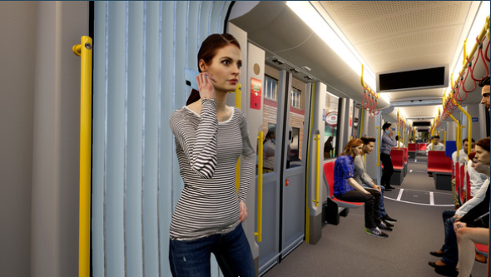This video shows an underground train, somewhat like a tram. I like the fact that the train slows down when something cool is happening so you can see it through the windows.

‘TramSim Vienna- The Tram Simulator’ is similar to the Half Life intro because it’s a moving tram. The tram is very realistic and has a sign on the front. I liked that it looked like a realistic city, and because Nottingham is a city I thought it would be a good way to show Nottingham because Nottingham has a tram.

I also liked that weather is in the game and am thinking about including this in my game, and I liked the AI of people getting off and on the tram.

Out of the two of these products I prefer the Tram Simulator AI feature, as Half Life feels empty, and more like an underground train, so it’s quite dark. I prefer Tram Simulator AI because it has realistic AI, and that makes the tram more realistic as you wouldn’t have a tram going round the city with no one on it.

I also think the camera in Tram Simulator is better because you can see inside and outside of the tram, so I think I will try having a camera that moves in my final game, and add AI.

**Put this with your ideas before you chose your final idea:**

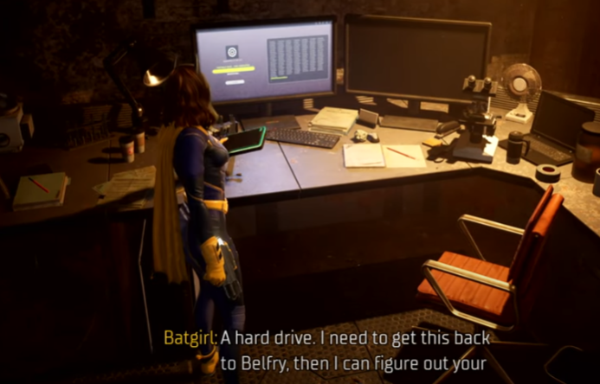**Batman Arkham Knights and Gotham Knights**

In ‘Batman Arkham Knights’ and ‘Batman Gothic Knights’ you can zoom in to learn more about items. I like the idea of using this method of interacting with objects to learn more about them. I think this could be educational as it would allow people to know what to interact with and then learn more about things.

I also like that in these games there is someone talking through an earpiece so you can hear what is said but also you can read it if you can’t hear, or if you miss some information.

* **Get rid of alien link**

